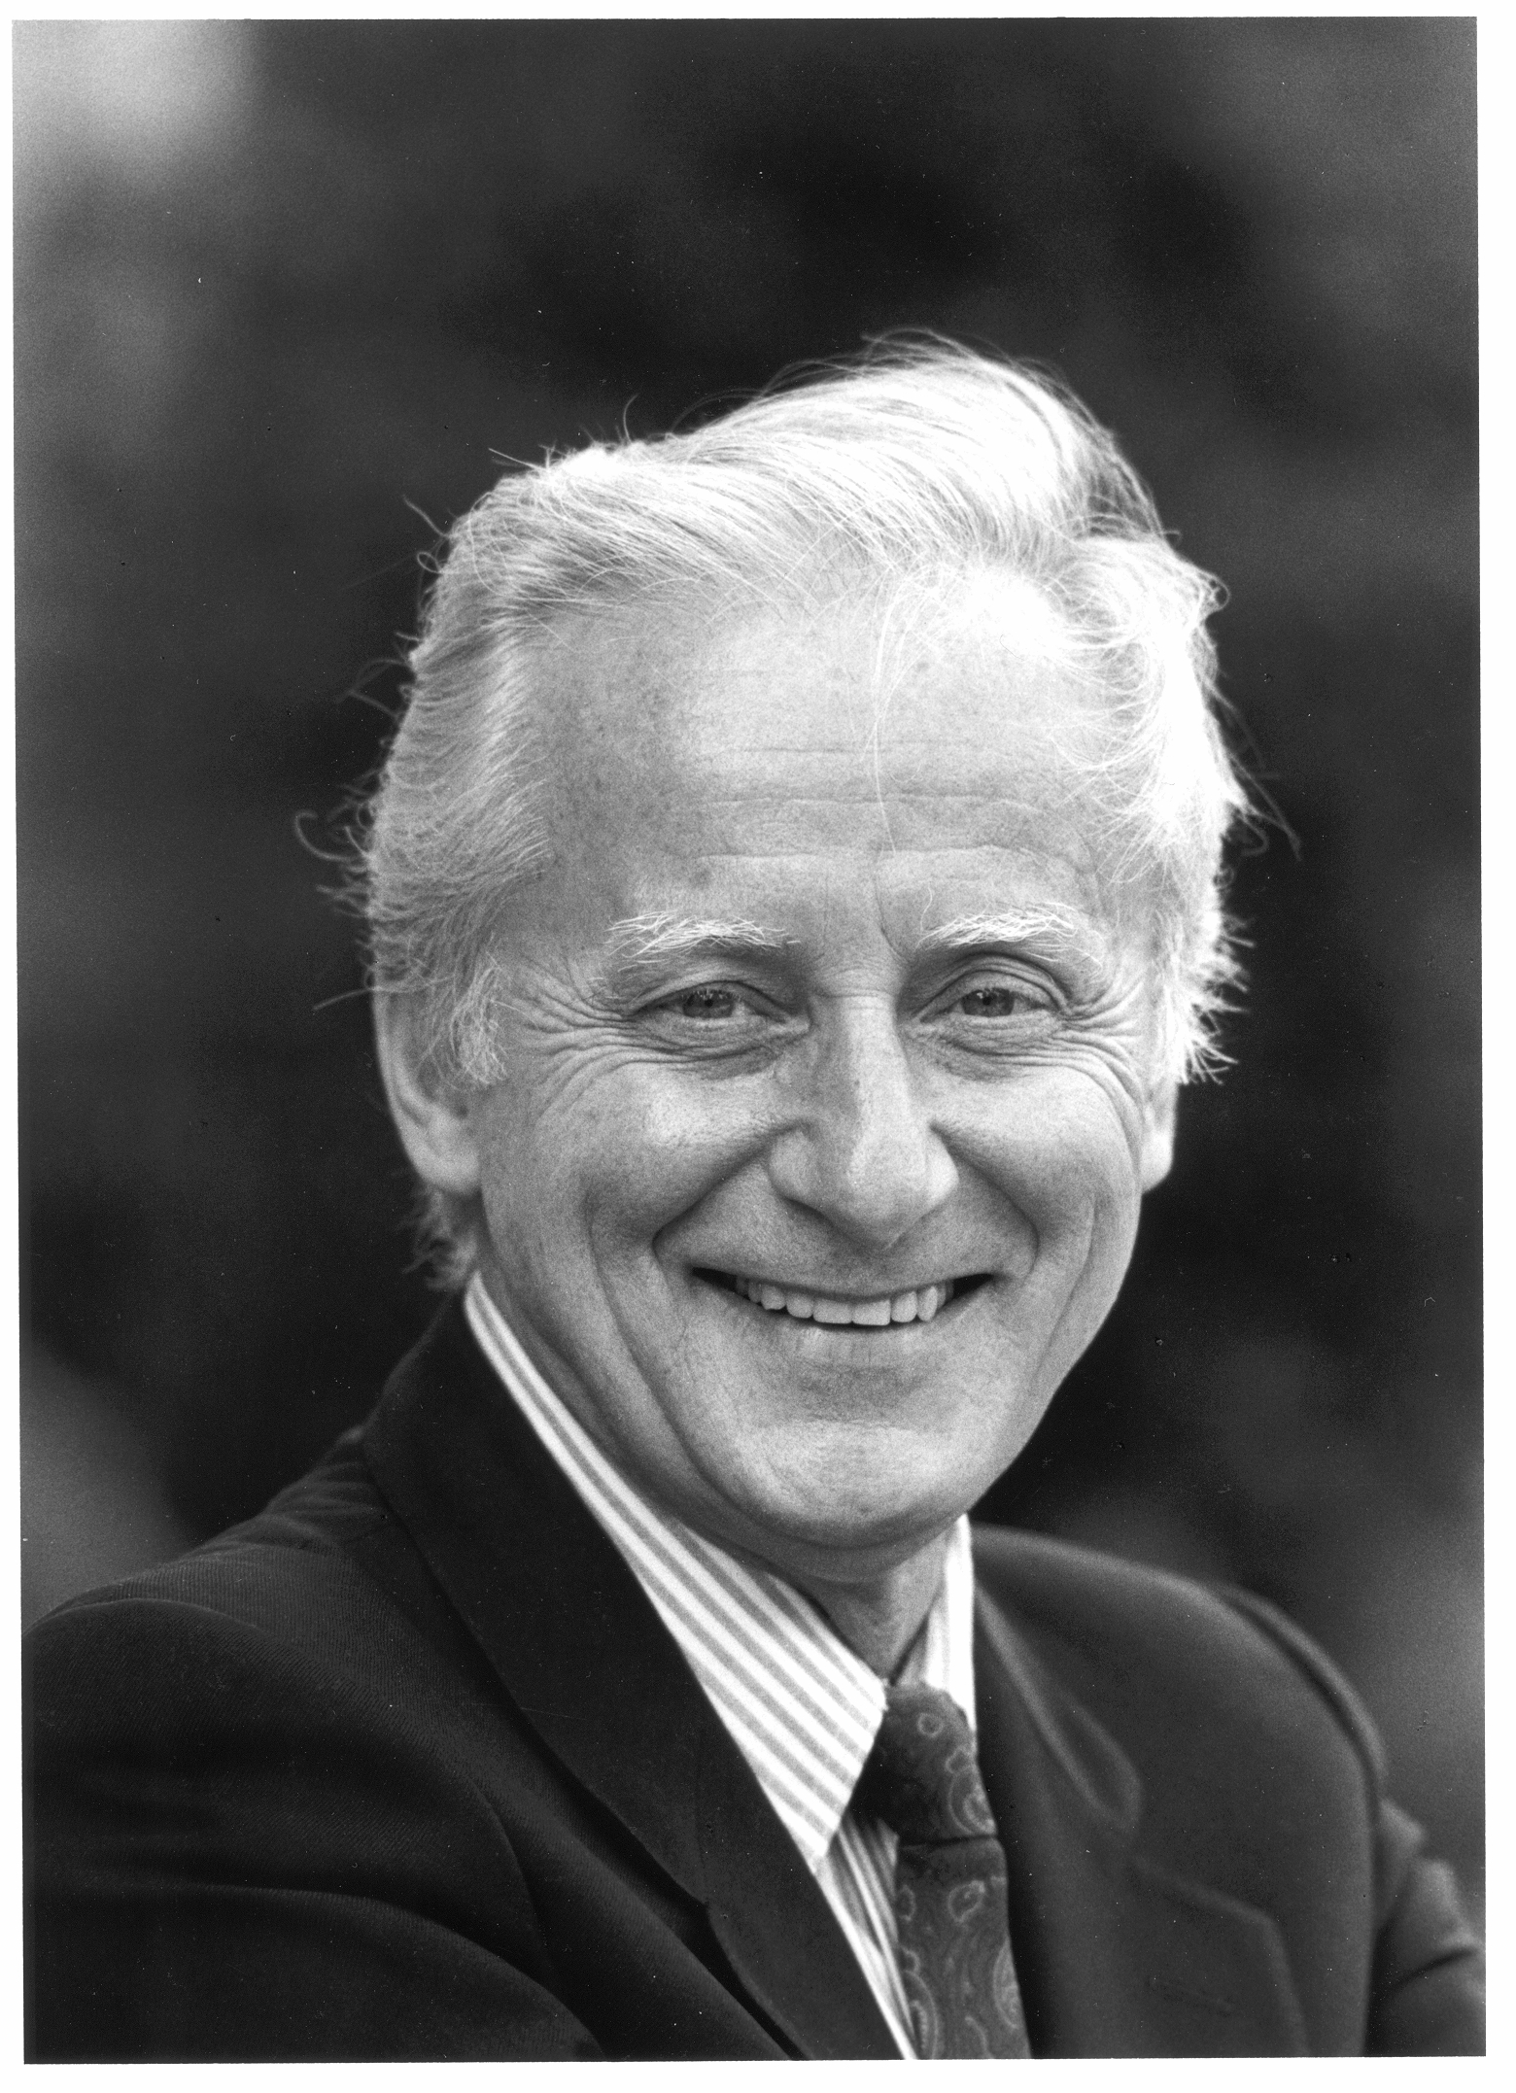

Philosophy in Theological Education

A Conference in Honor of Professor Ralph McInerny

Ave Maria University
Ave Maria Florida
10-12 February 2011

February 10, 2011: Pre-Conference Presentations by AMU Doctoral Students:

2:00-6:00 Registration for the Conference outside the Student Union Ballroom

3:30-6:00 Four twenty minute student presentations in Conference Ballroom.

Moderator: Dr. Michael Waldstein (Ave Maria University)

John Froula: Maritain & McInerny on Natural Law
Irene Alexander: Aquinas & DeKoninck: On Marital Common Good
Jared Kuebler: Mariology of Charles DeKoninck
Susan Waldstein: Mercy & Evolution in Charles DeKoninck

Respondent: Fr. Michael Sherwin, OP, (University of Fribourg)

6:30 Presentation of the Aquinas Center Awards &
Cocktails & Dinner for participants in Executive Dining Room

8:00pm-9:30pm Keynote Lecture

Moderator: Dr. Roger Nutt (Ave Maria University)

Fr. Charles Morerod, OP, “All Theologians are Philosophers whether knowingly or Not” Demeetree Lecture Hall

February 11, 2011 Friday:

7:30 am Mass for Conference Participants in the St. Joseph Chapel

8:00-9:00 Continental Breakfast in Lounge of Xavier Hall

9:30 -12:15 Metaphysics, Theology, & Nature
Sessions in Ball Room Lecture area

Moderator: Dr. Mark Johnson (Marquette University)

9:30-10:10am Fr. Lawrence Dewan, OP, (Dominican University College) “Theology and the Metaphysics of Creation”

10:10-10:40am Dr. John O’Callaghan, (University of Notre Dame) “Legitimacy of Philosophy as an Autonomous Discipline & Its Genuine Service to Theology in Aquinas and Ralph McInerny”

10:40-10: 55 Coffee Break

Moderator: Dr. Gary Culpepper (Providence College)

10:55-11:35am Fr. Joseph Koterski, SJ, (Fordham University) “The Concept of Nature: Philosophical Reflection in Service of Theology”

11:35am-12:15pm Dr. Steven A. Long, (Ave Maria University) “On the Natural Knowledge of God: Aquinas’s Debt to Aristotle.”

12:15-1:45pm Informal lunch in Cafeteria or Bean.

2:00pm-5:00pm Reason and Revelation

Moderator: Dr. James Keating (Providence College)

2:00-2:40pm Dr. Kevin White (Catholic University of America) “Philosophical Starting Points: Reason & Order in Aquinas’s Prologues to Aristotle”

2:40-3:20 Fr. Timothy Bellamah, OP, (Dominican House of Studies) “Tunc scimus, cum causas cognoscimus: Notes on the Medieval Endeavor to Know Scripture in Its Causes”

3:20pm-3:40pm Coffee Break

Moderator: Dr. Robert Barry (Providence College)

3:40-4:20pm Fr. Brian Daley, SJ, (University of Notre Dame) “Rediscovering Christian Sources: Philosophy and the Retrieval of Tradition in Twentieth-Century Catholic Theology”

4:20-5:00pm Fr. Guy Mansini, OSB, (St. Meinrad Seminary) “Robert Sokolowski and the Christology of Disclosure”

6:00pm-6:45pm Reception & Cocktails in Executive Dining

6:45pm- Conference Banquet in Ball Room Dining Area

February 12, 2011 Saturday:

7:30 am Mass in St. Joseph’s Chapel

8:00 am – 9:00 am Continental Breakfast in Xavier Hall Lounge.

9:30 -11:15am Philosophy in Trinitarian Theology

Sessions in Ballroom

Moderator: Dr. Lawrence Welch (Kenrick-Glennon Seminary)

9:30-10:10am Fr. Gilles Emery, OP, (University of Fribourg) “Central Aristotelian Themes in Aquinas’s Trinitarian Theology”

10:10-10:40am Dr. John Boyle (University of St. Thomas) “Aquinas on the Procession of the Holy Spirit”

10:45-11:15am Dr. Michael Dauphinais (Ave Maria University) “Christ and Revelation in Aquinas”

11:15-11:30am Coffee Break

11:30am – 1:00pm Philosophy in Marian Theology

Moderator: Fr. Thomas Petri, OP, (Providence College)

11:35am-12:15pm Fr. Romanus Cessario, OP, (St. John Seminary) “Ego Sapientia: The Mariology of Laval Thomism”

12:20pm-1:00pm Fr. Kevin Flannery, SJ, (Pontifical Gregorian University) “Reflections on Ralph McInerny’s Dante & the Blessed Virgin Mary”

1:00pm-2:30pm Lunch

2:50pm-5:10pm Philosophy and Moral Theology

Moderator: Dr. Paul Gondreau (Providence College)

2:50pm-3:30pm Fr. Thomas Joseph White, OP, (Dominican House of Study) “Aquinas's Imperfect Happiness and the Ideal Paradigm of Nature-Grace Orthodoxy”

3:40pm-4:20pm Dr. Marc Guerra (Ave Maria University) “Moderating the Magnanimous Man: Aquinas on Greatness of Soul.”

4:20pm-4:30pm Coffee Break

4:30-5:10pm Fr. Sebastian Walshe, OPraem, (St. Michael Abbey) “Charles DeKoninck and Aquinas’s Doctrine on the Common Good.”

6:00 onwards Cocktails and Dinner for participants at Condo Terrace

8:00 Closing Tribute to Ralph McInerny: Ambassador Michael Novak

