Neighborhood Wildlife Photo Journal
Big-Hearted Families Book Club June 2013

Get inspired by this month’s book!
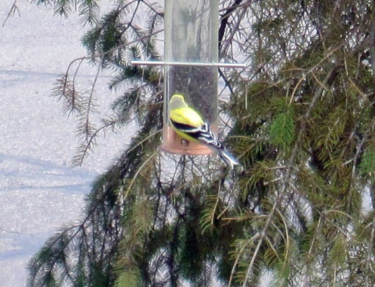
You’ve read The Great Kapok Tree: A Tale of the Amazon Rain Forest by Lynne Cherry. Now spend time with your family noticing the creatures and plant life that live near you.
The more we notice and learn about the ecosystems around us, the more we will understand about the big idea of interdependence. And the more inspired we will be to protect the living things that share the earth with us.

Activity Supplies:
- camera
- binoculars (optional)
- small photo album
- small, sticky labels
- pen/pencil
- books about local birds, bugs, mammals and trees, or internet access

First, take a hike:
Gather your family – plus the camera, the sunhats and some snacks – and go for a walk. You can start in your own backyard, a nearby park or a favorite wilderness area. Be ready to take a picture if your child sees something to add to your photo album.

You might find a favorite tree, an interesting bug or a sweetly singing bird. Here are a few things to think about:

> What can you do to make it easier to spot your creature neighbors? Things like walking softly, whispering, and using your senses to hear, smell or see small things you might otherwise miss will help a lot.
> What is different about your natural neighbors compared with those in the rain forest?
> What is the same?
> What creatures or plant life did you miss? What were you hoping to see that didn’t show up?

Second, get to know your neighbors:
Once you’ve photographed a handful (or more!) of specimens, head home to download and print your pictures, or take them to be developed.

Do some research to learn a bit about each photographed friend using library reference books or the internet. What is its name? What does it eat? Where does it like to live? What are its habits? Is it native to the area?

Third, assemble your photo album:
Arrange the photos in your album.
Write the name of each creature or plant on a label, along with your favorite fact about it, and add that to the album as well. You might also want to note where you saw it, and when.
Consider adding more discoveries to your album as you encounter new natural neighbors throughout the summer!

