Heart Beet Cookies
Brought to you by

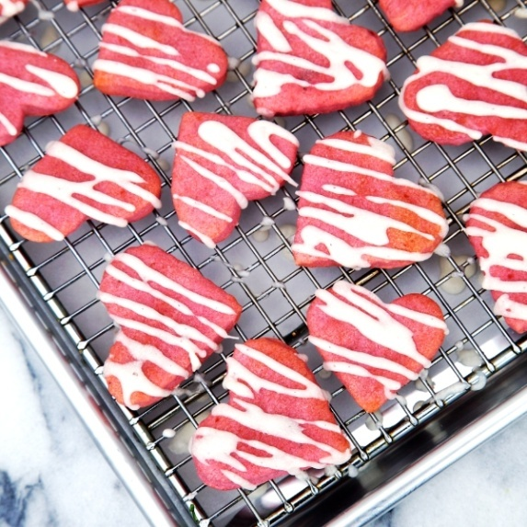
Miss Tizzy shares her heart with her neighborhood, and now your family can too! The Kids Cook Monday! has paired our big-hearted friend with this great vegan recipe.
These dairy-free cookies get their gorgeous pink hue naturally from beet puree. Kids will have fun rolling out the dough, cutting the cookies into shapes, and drizzling on the powdered sugar glaze.

This recipe comes to us from Donna Kelly of Apron Strings: apronstringsblog.com. Visit thekidscookmonday.org for more great recipes for your young chefs.
Enjoy a few cookies during story time, and add the rest to goodie baskets to share with neighbors.
Ingredients

- 1 (15 ounce) can diced beets
- 1/4 cup almond butter
- 1/2 cup sugar
- 1/4 teaspoon salt
- 1/4 cup vegetable oil
- 2 cups all-purpose flour
- 1 cup oat flour
- 2 teaspoons baking powder
- 2 cups powdered sugar

Directions
Adult: Preheat oven to 400 degrees.
Kid: Grease your cookie sheet using a small dab of butter on a paper towel.

Together: Drain beets and transfer to a food processor. Puree until smooth. Transfer to a medium mixing bowl. Mix the almond butter, sugar, salt and oil into the beet puree. Stir both flours and the baking powder into the beet-sugar mixture. Wrap dough and refrigerate for at least 30 minutes.

Kid: Whisk powdered sugar together with 3 tablespoons of water in a medium bowl until smooth to make a sugar glaze. Set aside.

Together: Roll dough out with a rolling pin so it’s 1/4-inch thick. Use a bit of powdered sugar to keep the dough from sticking.

Kid: Cut out cookies from the dough using a small heart-shaped cookie cutter. Add cookies

Adult: Transfer cookie sheets to the oven and bake for 15-18 minutes, or until the cookies are cooked through. Allow cookies to cool for 5 minutes.

Kid: Drizzle cookies with the powdered sugar glaze to taste, and enjoy!

Nutrition Information

Heart Beet Cookies
Servings per recipe: 8

Calories: 286.6
Calories from fat: 48
Total fat: 5.4g
Saturated fat: 0.5g
Cholesterol: 0.0mg
Sodium: 224.6mg
Total carbohydrates: 54.0
Dietary fiber: 4.2g
Protein: 7.7g
Sugars: 17.5g

