Our Family Loves You:

Veggie Print Thank-You Cards
Big-Hearted Families Book Club February 2013

Get inspired by this month’s book!
You’ve read Somebody Loves You, Mr. Hatch by Eileen Spinelli. Now, share some love and gratitude with the unsung heroes in your life.
In the beginning of the book, Mr. Hatch is a bit of a loner. When he believes he is loved, thanks to a mistakenly delivered Valentine’s package, he shares every bit of that love with his community. Though he later discovers that the package was sent unintentionally, his friendly, helpful attitude earned him everyone’s love by the end.

Take a moment to consider who in your community could use some extra love. Who crosses your path on a regular basis but often escapes attention? Our firefighters, mail carriers, garbage collectors, bus drivers, cashiers, and lonely neighbors all would make great recipients.

Use the following template, or your own creations, to share a card that expresses gratitude, appreciation, and neighborly love.
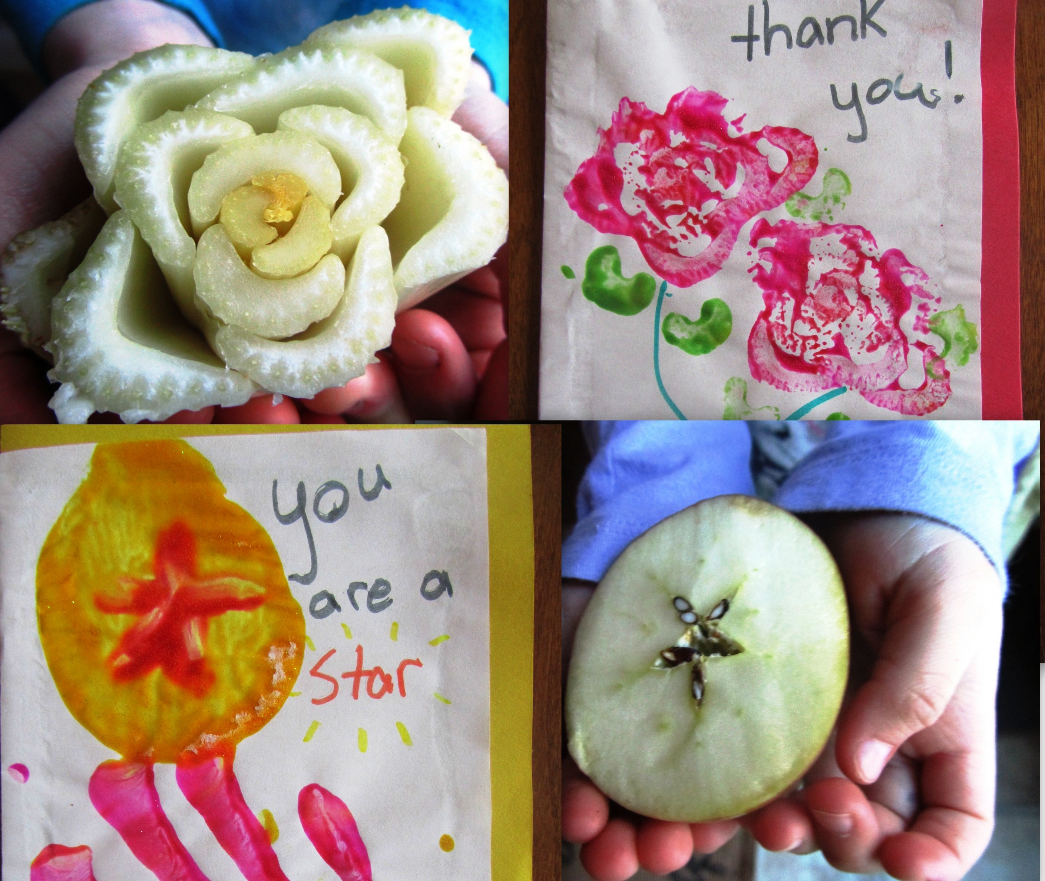
Ingredients:
1 bunch of celery
1 or 2 apples
Assorted craft paper (construction paper or card stock)
Paint (green, yellow, red, or your favorites)
Markers, crayons, or colored pencils
1 box of brownie mix (optional)

First, make your stamps:
Grab the bunch of celery stalks in one hand and slice them off all at the base cleanly and evenly. Have you ever noticed the rose shape created by the base? Use this to stamp flowers on your cards. Now slice one celery stalk in half. When you add a little green paint, it makes a nice leaf pattern.

Carefully slice the apples in half, horizontally. Notice the star pattern at its core. If you pluck out the seeds, you’ll have an even better defined star shape for your apple stamp.

Second, paint your cards:
Once again, we hope you’ll invite your kids to get a little messy. Put paint on your celery and apple stamps and create flowers and stars on your cards. Let the paint dry before proceeding.

Third, write your notes:
Once the paint is dry, write notes of gratitude and appreciation. Something as simple as “We love you” or “Somebody loves you” can do the trick. If you are thanking someone for a specific gesture or kindness, add that to your letter. Make it beautiful. Make it personal. Be sincere.
Bake brownies to share (optional extra effort):
If you would like to follow Mr. Hatch’s lead, bake a treat to leave with your card. Feel free to use a mix -- or make your favorite brownie recipe.
Fourth, deliver your notes:
“Keeping to himself” was a big part of Mr. Hatch’s problem initially. Taking time to greet, thank, and show concern for the people in his community soon filled his life with friends and love. As you deliver your creations, take the opportunity to strike up a conversation with someone you may not speak to often.

