May 2, 2013

Lack of Medication Adherence Harms Americans’ Health
Results from a U.S. National Survey of Adults

To: | Interested Parties
From: | Greenberg Quinlan Rosner Research  Public Opinion Strategies

A recent poll of American adults shows that nearly two-thirds of Americans who take prescription medications are non-adherent, meaning they are not taking their medications as prescribed by their doctors. This has real implications on Americans’ health. Almost half of all Americans have one or more chronic disease with effective medications available for many of these conditions. Those patients who report not taking their medications as prescribed report poorer health than those who always take medicines properly.

People taking medications face many challenges, such as consistent timing, interactions with food or other medicines taken, and not understanding why the need to take their medicine as prescribed. However, there are opportunities to make it easier for Americans with chronic conditions to adhere to their prescription regimens, improving their quality of life and health outcomes. These opportunities include increasing communication between patients and health care professionals about taking medications as prescribed and the consequences of not doing so, better coordination of care, providing more information about medications, and improving access to tools that can help those taking medications remember to take them properly.

The results in this memo are based on a national poll of adults, conducted by Greenberg Quinlan Rosner Research and Public Opinion Strategies for the Council for Affordable Health Coverage. The survey reached a total of 800 adults and was conducted April 3 – 9, 2013. The margin of sampling error for the sample is +/- 3.5 percentage points at a 95 percent confidence level.

Key findings from the survey include:

- Nearly two-thirds of Americans who take medications do not take them properly. Sixty-four percent of Americans who take medications report that they are not always taking their medications as prescribed, while only 33 percent say they never miss taking their prescription medications. Those who face the challenge of managing multiple medications are most likely to not adhere; 70 percent of individuals who take 3 or more medications do not take them properly, compared to 56 percent among those with 1 or 2 prescription medications.

- Individuals who don’t take their medications properly report feeling less healthy than those who take their medications as prescribed. Those who take their medicines as prescribed are much more likely to report feeling excellent or good about their own health (87 percent) compared to those who don’t always take medications (65 percent).

Figure 1 – Medication Adherence vs. Health

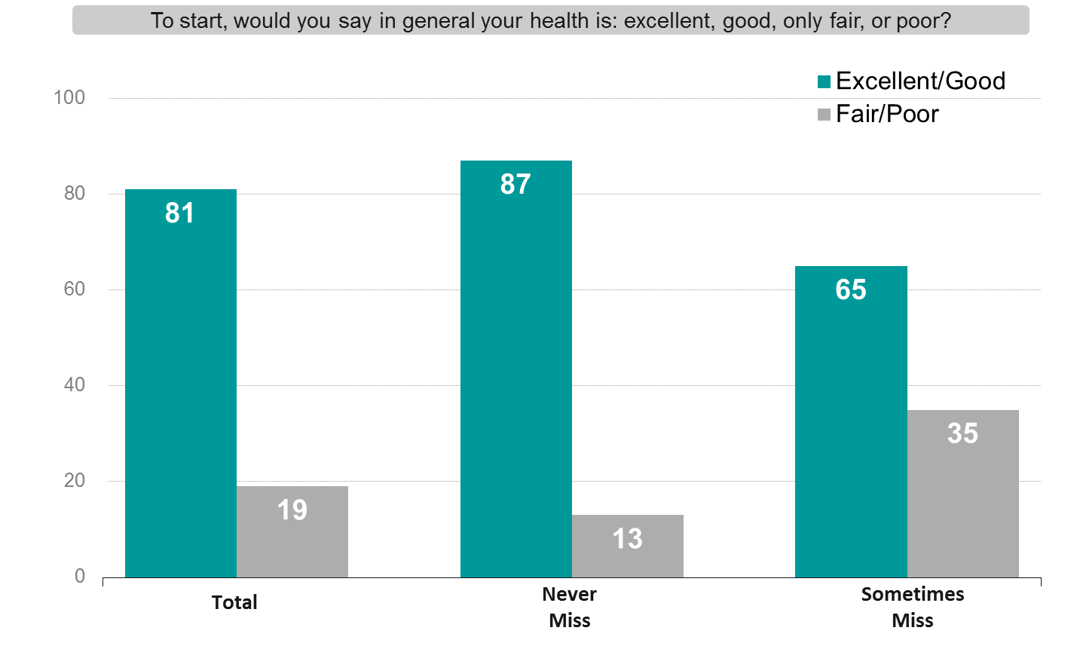

- Americans are supportive of making tools available to help individuals adhere to their medication regimen. The majority of Americans say the changes and proposals we tested can be effective in making it easier for those managing chronic conditions to adhere to their medications. They view a few recommendations as most likely to be effective:

  - Increase one on one communication between patients and health care professionals about medications and the consequences of not taking them as prescribed (89 percent effective) and give clear information about the individuals’ medications (92 percent effective).

  - Improve coordination of care and information on medications. This includes changes that can help patients sync up refills for multiple prescriptions at the same time (87 percent effective), as well as better information technology that allows all of a patient’s health care providers accurate information about the patient’s filled prescriptions (89 percent effective).

  - Provide access to tools that help those taking medications remember to take their medications properly, including things like pill boxes and applications for mobile phones to help track medications (86 percent effective) or email and phone reminders (77 percent effective).

Robert Wood Johnson Foundation. Chronic Disease: Making the Case for Ongoing Care. February 2010. Available at: www.rwjf.org/pr/product.jsp?id=50968.
These respondents are defined as those who say they: they have difficulty remembering to take their medication all of the time, usually, sometimes, once in a while, or rarely AND those respondents who said they did not take their medication the way it was prescribed today, days ago, weeks ago, months ago, or a year or more ago.

