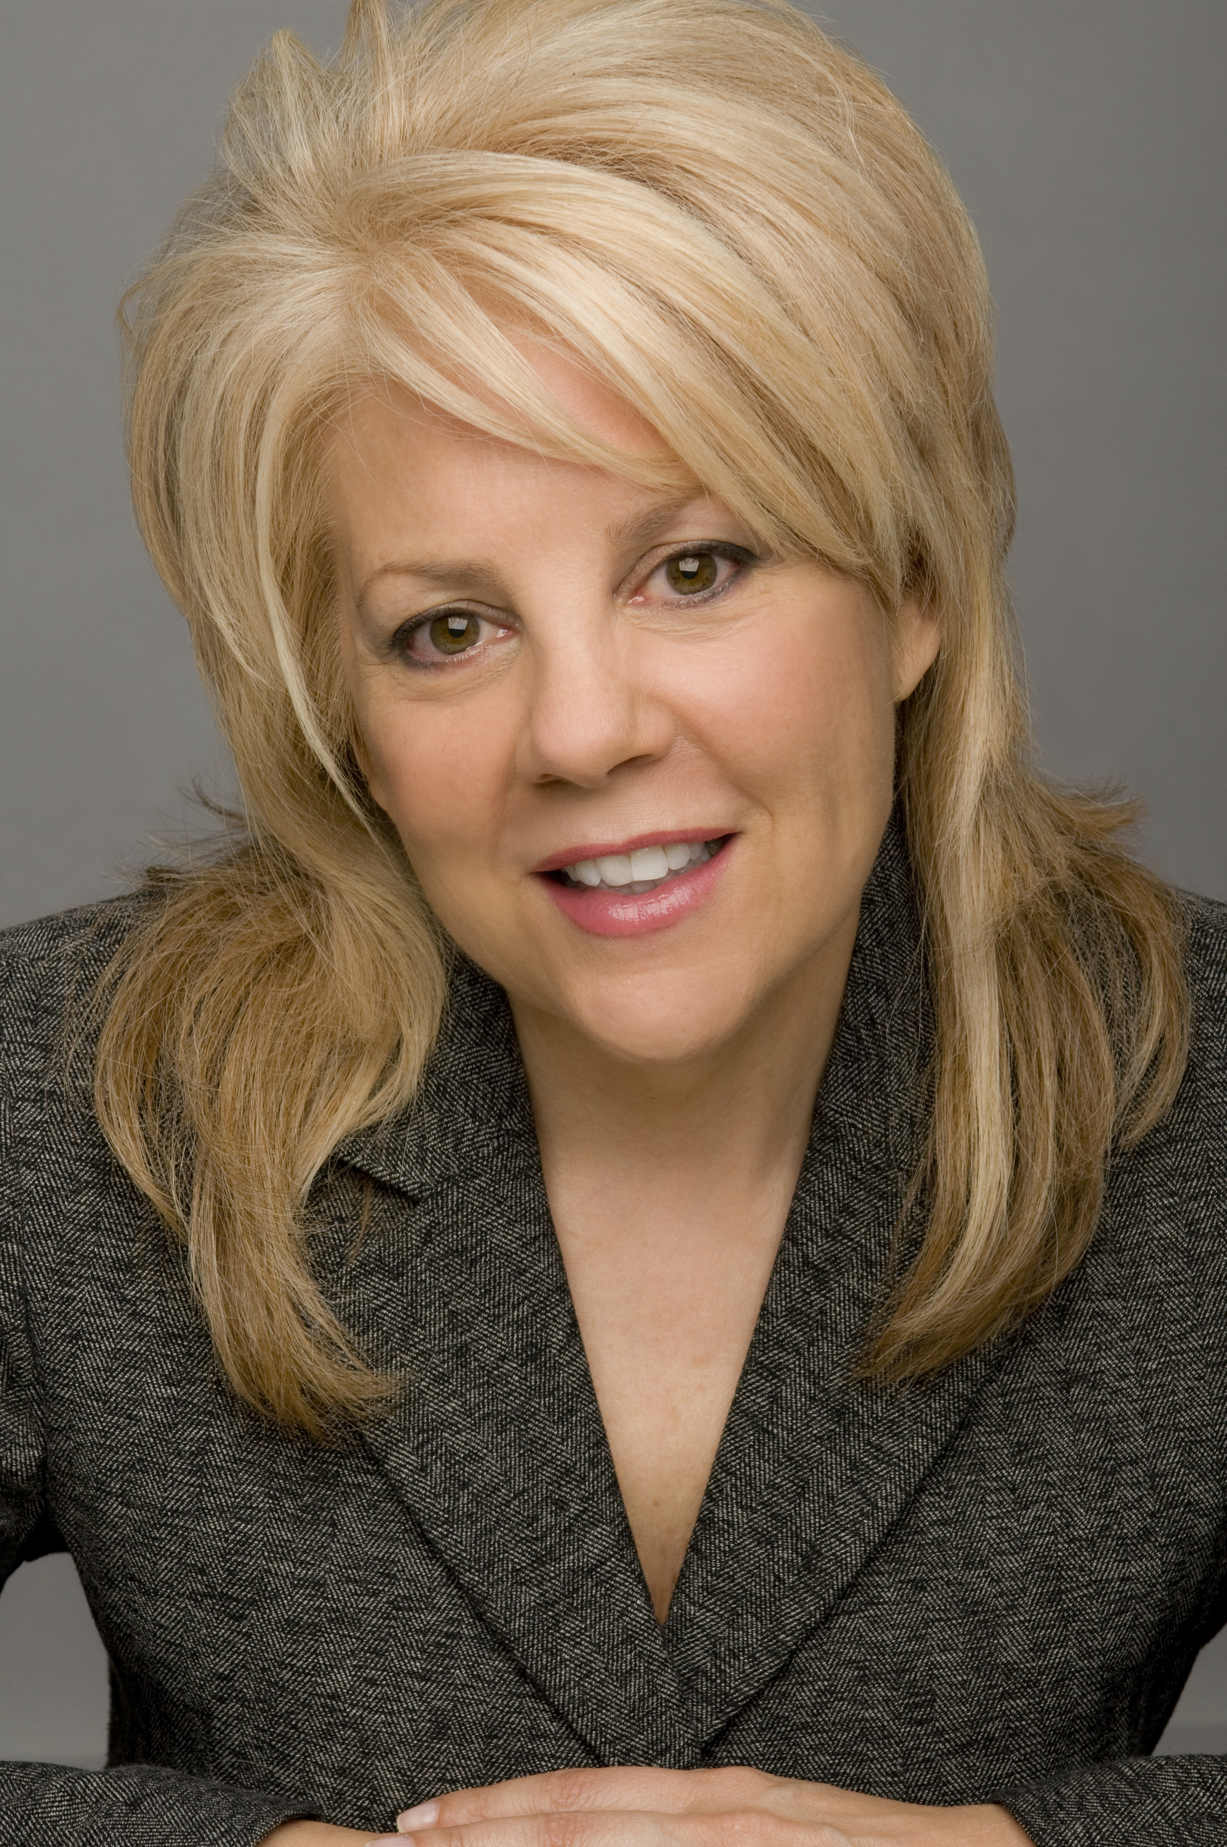

ICSEW proudly presents a half-day seminar on Monday, November 22, 2010...

How to Excel in a
Stressful Work Environment

Meet Your Speaker
Sandra Smith is a popular speaker, the president of Aspire Seminars, and author of the book Get What You REALLY Want Without the Guilt—which was recently voted Reader’s #1 Fan Favorite.

Exciting news! Aspire Seminars just launched a new Web site!
It’s full of tips and strategies to help you succeed.
www.lifeisfabulous.com

Learn how to become full of energy, motivated, and a top-performing employee―
no matter how stressed you are in your current work environment



www.aspireseminars.com ⋅ sandra@aspireseminars.com
360.539.9080 ⋅ 866.788.0723 ⋅ Fax 866.826.8361

What You’ll Learn When You Attend...
• Create positive energy when you feel burnt out, stressed, or tired
• Empower yourself to be assertive and deal with negative people
• Develop a method for handling work situations that seem unmanageable
• Execute the self-control skills to deal with conflict and confrontation positively
• Identify and remove obstacles so you can utilize your strengths
• Make work more enjoyable, easier to handle, and go home full of energy

This seminar will help you handle stress at home, too!

TWO EASY WAYS TO ENROLL
On-line: http://www.icsew.wa.gov (Training)
Or — Call Sandra Smith (the trainer) at (360) 539-9080

If you have questions, please contact:
ICSEW Chair Genevieve O’Sullivan, icsew@sao.wa.gov, 360.725.9704
ICSEW Trainer Sandra Smith, Sandra@aspireseminars.com, 360.539.9080

SEMINAR LOCATION
Labor and Industries
7273 Linderson Way SW, S117
Tumwater, WA 98501-5414

Monday, November 22, 2010
9:00 a.m. – 12:00 p.m. OR 1:00 p.m. – 4:00 p.m.

Please mail check for seminar to:
Aspire Seminars
PO Box 3603, Lacey, WA 98509-3603
FEIN Tax ID# 91-2012795
See Your There!

COST
Just $89 per person. Cancellations must be made two days prior to the seminar. Substitutions will be accepted through the day of the event. Didn’t get to register yet? No worries. Walk-in’s always welcomed!
Aspire Seminars Vendor Number: SWV0037254-00

Client Comment
“Sandra Smith’s workshops exceeded our expectations for success. She was the audience favorite!”
Teresa Herrera Dept. of Social and Health Services

Join Us Monday, November 22, 2010

